The Ohio State University First-Year Seminar Program Course Proposal
Course Information
1. Attach a sample syllabus that includes the following. (Sample syllabi can be found at http://firstyearseminars.osu.edu).
- • the course goals
- • a brief description of the content
- • the distribution of meeting times
- • a weekly topical outline
- • a listing of assignments
- • grade assessment information (A-E or S/U)
- • required textbooks and/or reading list
- • the academic misconduct and disability services statements (sample statements can be found at http://asccas.osu.edu/curriculum/asc-syllabus-elements)
2. Attach a brief biographical paragraph that includes the current research interests, teaching awards and honors, and undergraduate courses taught by the participating instructor(s). The paragraph will be included in materials for first-year students.
Proposer’s Name and Primary Academic Unit (please print) : Linda Mizejewski
Proposer’s Title: The Unruly Woman: Contemporary Women’s Comedy
Proposer’s e-mail Address Contact Phone Number : Mizejewski.1@osu.edu; 614-256-8251
Submission Date: Feb. 20, 2018
Approval of Department Chair of Academic Unit (please print)
Shannon Winnubst
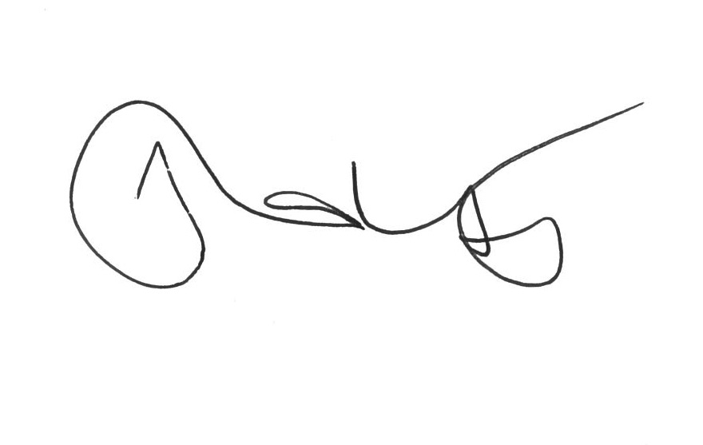
This form and any attachments should be mailed to First-Year Seminar Program, 100 Denney Hall, 164 Annie & John Glenn Avenue, ATTN: Todd Bitters or e-mailed to bitters.4@osu.edu.
2/5/2018 tab

